**Final Project – Saurabh Joshi**

**Evaluating problem of forest fires in southern California through GIS**

**Abstract**

Geographical Information System (herein GIS) has over the past few years changed the way in which emergency planning and response is handled. Forest Fires in southern California have caused massive loss of life and damage to the property over many years. The project explores use of GIS data using software such as ArcGis Pro in understanding the problem of forest Fires in Southern California and possible ways of preventing and containing future cases.

**Problem Statement**

Forest Fires in Southern California over several years has cause loss of life and destruction of property.

**Introduction**

Forest fires are one of the common natural disasters which occur around the world causing large loss of life and property. As the effect of climate change worsen in next few years leading to more forested areas going through dry spell the challenge of deadlier forest fires will continue. The relationship between climate change and forest fires is also other way round as destruction of large forest will have direct impact on the climate change. This is direct affect to the sustainable development goal of climate change set by United Nations. California has suffered the impact of forest fires for many years. 2018 was the worst year in history with close to 9000 fires destroying almost 2 million acres of land. [3] Camp and Woolsy fire caused a loss of upto $13 billion in estimates making them one of the worst episodes of forest fires ever. [5] There were total 98 civilian deaths and 6 firefighters suffering fatal casualties. Camp fire which began on November 8, 2018 was deadliest and most destructive fire in the history. Forest fires can cause a severe impact to the local communities. Loss of life and destruction of properties can have far reaching effects, both physically and mentally, for people in the communities. This is where GIS can help in prediction, preparation and even containment of the forest fires.

**Objectives**

The main objective was to find various patterns and possible solution using GIS which can potentially help in in initial prevention and possible containment of fires in area of Southern California. One of the goals was to demonstrate use of readily available GIS datasets in emergency prevention and response.

**Datasets**

For this project there were several Raster and Vector data set required in order to appropriately carry out detailed analysis. Most of the data for the project was readily available on the California government websites. Following were the source and data collected for this project.

1. ca.gov Cal Fire

Data collected:

* Vegetation (Vector Data), Terrain (Raster Data), Facilities (Vector Data), Fire Threats (Raster Data).

2. California Department of Transportation

Data collected:

* Network analysis of Roads (Vector data)

**Methodologies and Observations:**

The initial step undertaken during the development of the project was to understand and evaluate existing data available online. Forest fires can arise due to multiple both human and natural. Human factors may include lapses while creating bonfires to improper disposal of Cigarettes. Sometimes there are cases where some elements in the society purposefully try to harm the forested areas. These can also result in forest fires getting out of control. Climate change is the phenomenon which certainly has increased the risks of forest fires over last few years. [3] In California, drought conditions have increased over last few years which increased the risk of Forest fires. Heavy Wind factors can also affect the plight of fire intensity as wind is one of the primary factors which help spread of wild fires.

One of the most important factors that we can look using GIS is vegetation area to assess the impact in case of forest fires. Figure1. Shows the map created using ArcGis Pro in counties of Southern California. From the map it was seen that even though there is presence of large cities like Los Angeles and San Diego in Southern California, large areas surrounding these cities are covered in heavy forest. It was also seen that large amount of population lives around protected forest areas like National Parks. Combination of heavy populated areas surrounded by forest can have significant impact in case of forest fires. During forest fires evacuation of the residents becomes top priority.

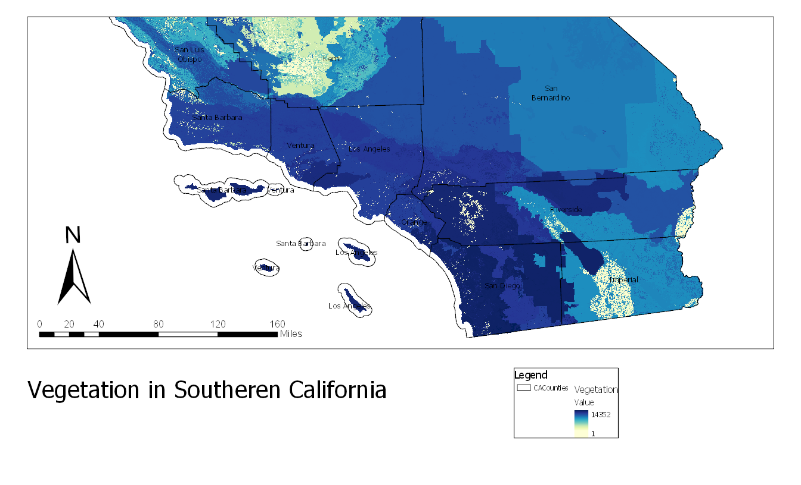

Figure .Vegetation in Southern California

Each county will have different areas which are prone to fire hazard. A dataset was found on cal fire site which was used to map areas which are more prone to forest fires. A significant number of areas which are heavily populated can be seen right inside the Hazard zones. This map along with layer of map using vegetation can be used by urban planners and forest authorities to prepare contingency plans in case of the forest fires. In case of an incident such types of maps can help in evacuation of the citizens from the areas.

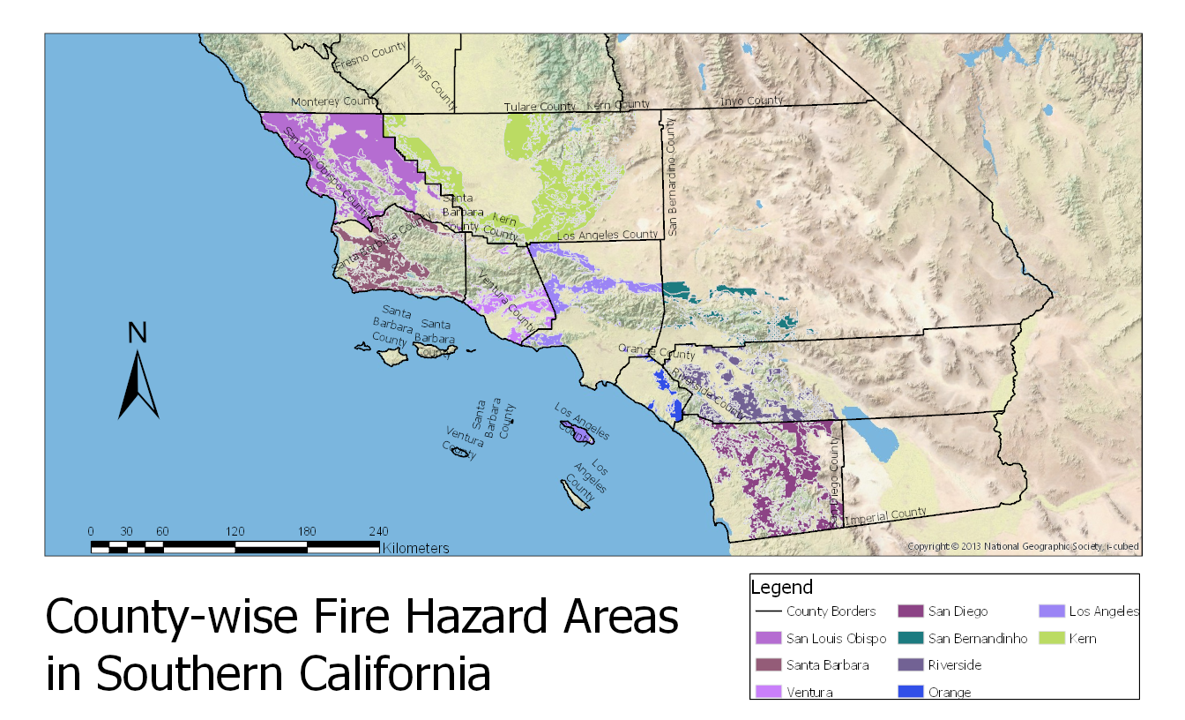

Figure . County-Wise Fire Hazard Areas in Southern California.

Being a large state and having faced several incidents of Forest fires each year, California has invested large amount of resources in fighting this menace. Several Fire stations have been created just to tackle wildfires in California. Also significant is the contribution of volunteer fire fighters. A hot spot analysis was conducted on the ways the fire station across southern California were distributed. One observation seen was there is a significant amount of fire stations available to tackle the blaze. It was seen that most of the fire stations are stationed inside urban clusters. These include local fire station. One of the reason can be that it will be ill advised to locate fire station exactly inside forested areas as they themselves can fall to forest fires. This can result loss of critical systems during critical time. Such kind of hotspot analysis can help in finding distribution of resources.

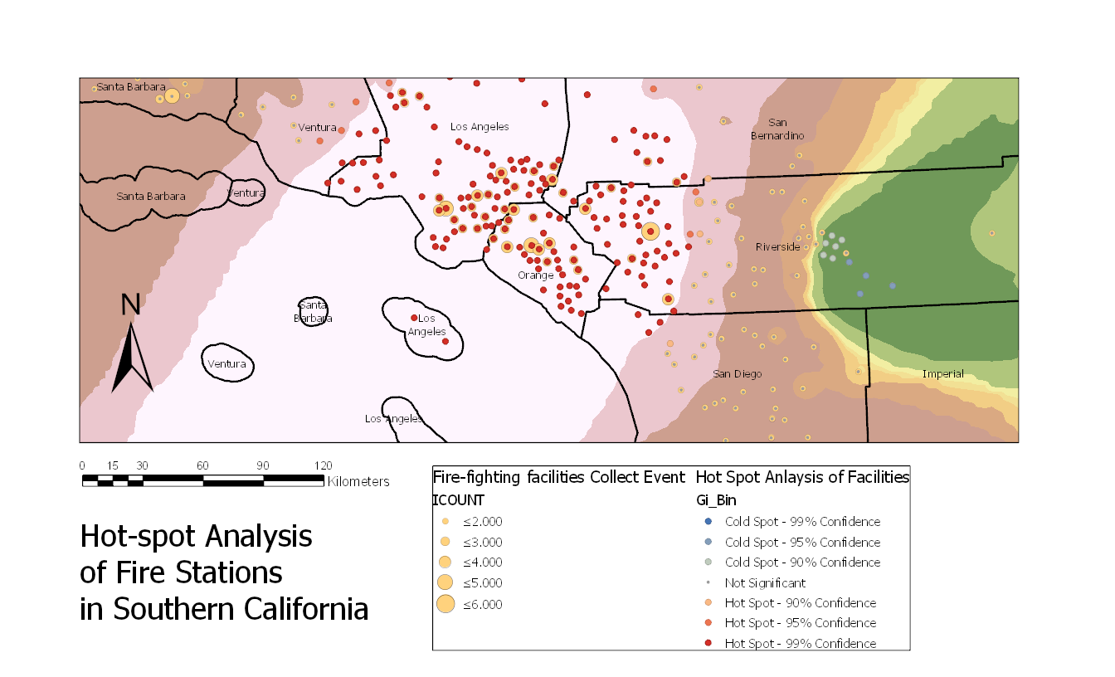

Figure . Hotspot Analysis of Fire Stations in Southern California.

Emergency management has become one of the primary roles of GIS over last few years. Like any other natural calamity GIS has also found its use in tackling the problem of forest fires. Advantage of GIS is that it can help before, during and after a calamity has stuck. With the available data areas which are most vulnerable to the forest fires, including areas which shows more number of cases of fires emanating can be highlighted on the maps. Resources are key to fighting the forest fires and GIS can help station resources better in case of future mobilization. [1]GIS can be implemented using previous data like vegetation cover, previous incidents and vector or raster data of locations. In the figure 1, vector data for the state of California consisting of previous threats and fire fighting facilities available was implemented. This is just one of the example of how GIS can be used to tackle forest fires. GIS can also make use of current data like wind conditions and temperature patterns to manoeuvre fire-fighting systems in predicted positions. Advantage of having GIS can also be felt after any disaster has struck. [6] For example, the GIS can be used by the government to get proper understanding of were relief materials and equipment can be deployed. Provisions and aid can reach the people in need faster. Private companies like insurance firms can also take help of such kind of systems.

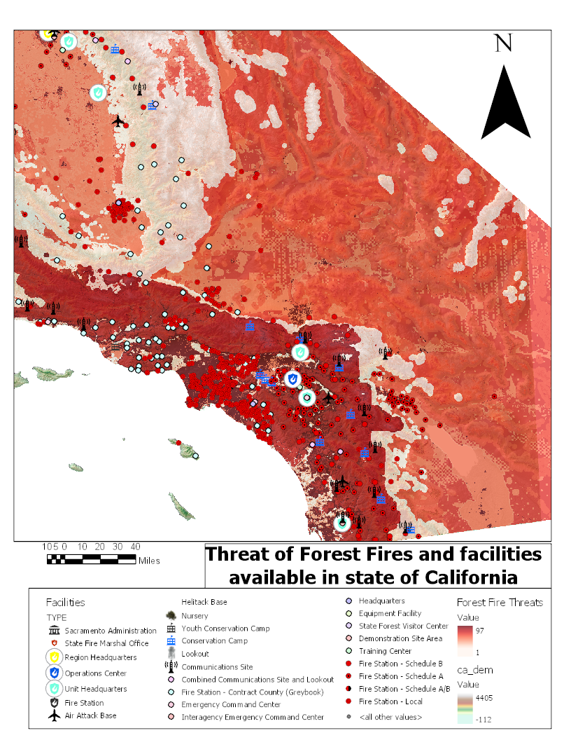

Figure . Threat of Forest Fires and Facilities available in State of California

Network analysis can also be conducted on how resources can be diverted to forest fires using GIS. Network analysis can be used to show significantly quicker routes and detours to be taken by fire engines during emergency.

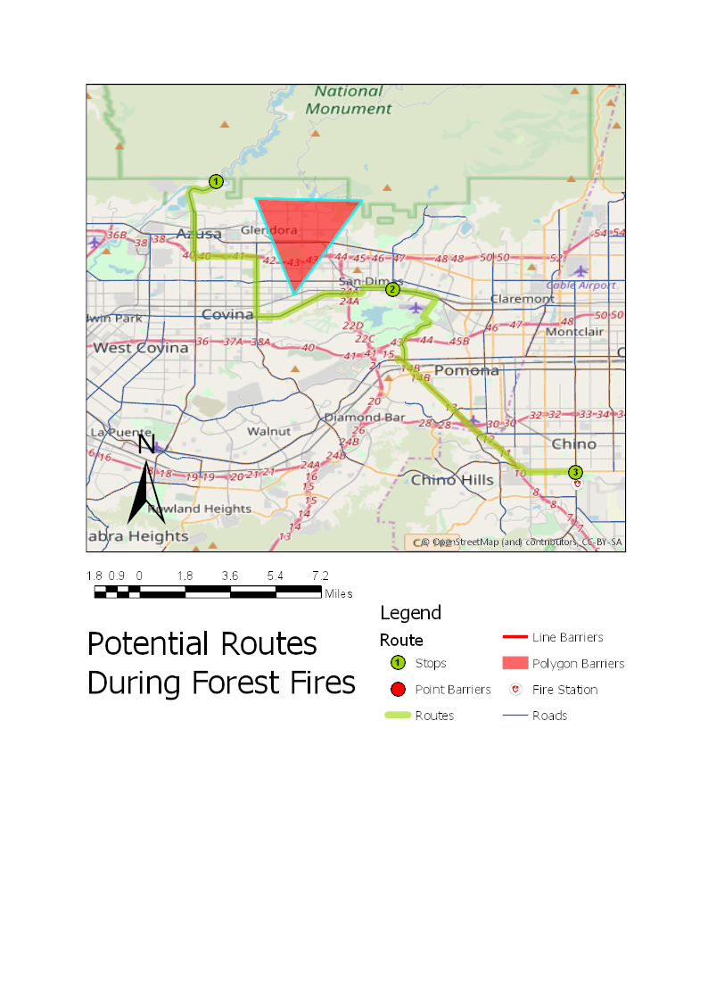

Figure . Network analysis of Routes during Forest Fires

[2]Forest fires impact sustainable development goals like Climate action, good health and wellbeing, life on the land and no poverty. Some way or the other like any other like all natural calamities forest fires affect communities in negative way. Like in 2018 several forest fires even before have claimed many lives in California and caused injuries for lifetime. Poor people are impacted even more as their homes get destroyed and they get sucked in menace of poverty even more. Forest fires affect a way of life for societies and cause mental trauma for years to come. As a result, systems like GIS can help in preventing negative impact on these development goals with their deployment in tackling disasters as demonstrated in above example.

**Future Work:**

One of the future works which can be considered is analysis on live data. This can consider several factors such as wind, temperatures along with already known datasets like vegetation. Working on live dataset can help significantly during event of crisis management.

**Conclusion:**

Through various theoretical and above-mentioned practical example it can be inferred that GIS can definitely be used to tackle menace like Forest fires. Although the above example emphasis on California, these systems can be deployed for almost any part of the world. As mentioned above any natural calamity like forest fire can have negative impact on sustainable development goals. Loss of life can be reduced and along with destruction of property and, mental and physical trauma, arising from it. Using GIS can help in achieving sustainable faster with more focus on saving lives and improving quality of life.

**References:**

1) Keeley, J., & Syphard, A. (2018). Historical patterns of wildfire ignition sources in California ecosystems. *International Journal of Wildland Fire*, *27*(12), 781-799. <https://doi.org/10.1071/WF18026>

2) Martin, D. (2019). Linking fire and the United Nations Sustainable Development Goals. *Science Of The Total Environment*, *662*, 547-558. <https://doi.org/10.1016/j.scitotenv.2018.12.393>

3) Modeler: Insured Losses from Camp Wildfire in California at $6B to $9B. (2018). *Insurance Journal*. Retrieved from <https://www.insurancejournal.com/news/west/2018/12/06/511240.htm>

4) N. Nauslar, J. Abatzoglou, and P. Marsh, “The 2017 North Bay and Southern California Fires: A Case Study,” *Fire*, vol. 1, no. 1, p. 18, 2018.

<https://doi.org/10.3390/fire1010018>

5) Stone, A. (2016, August 26). The Role of GIS in the Aftermath of a Wildfire. Retrieved from <http://www.govtech.com/em/disaster/The-Role-of-GIS-in-the-Aftermath-of-a-Wildfire.html>

6) Wootson, C., Jr. (2018, November 26). The deadliest, most destructive wildfire in California's history has finally been contained. *The Washington Post*. Retrieved from <https://www.washingtonpost.com/nation/2018/11/25/camp-fire-deadliest-wildfire-californias-history-has-been-contained/?utm_term=.8183025234fd>